- VOOLAY-VOO BUSINESS/PROMOTER WEB PANEL: When creating a new Event, if the “Save” button is clicked multiple times a corresponding number of the same event will be created multiple times once the Create Event PopUp disappears and Events are displayed.
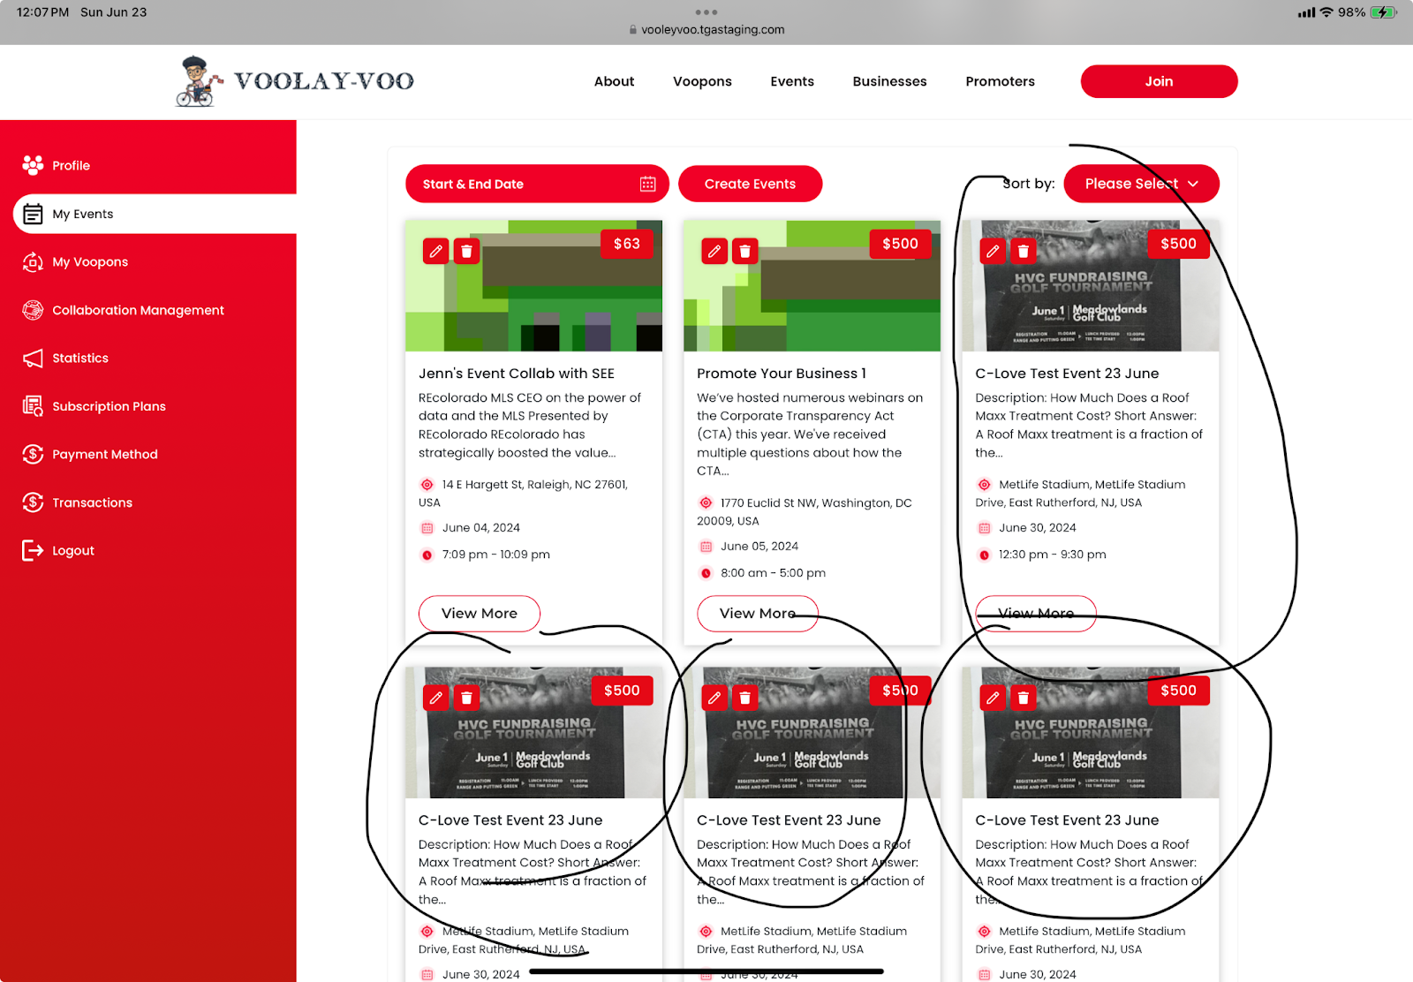

- VOOLAY-VOO BUSINESS/PROMOTER WEB PANEL: When editing a Completed Event, currently the date and other fields may be changed even though the event date has passed. This could potentially create an issue if the event was previously purchased by consumer users and if a user wanted to leave a review after the event had taken place.

- Add “Collaboration Management” text across platform to replace Lorem Ipsum sample text:
“If you would like to expand your market reach through networking and shared social-marketing events and activities, Voolay-Voo Business and Promoter Collaborators can help you accelerate the implementation of campaigns to enhance your business’ exposure, competitiveness, and revenue generating opportunities.”
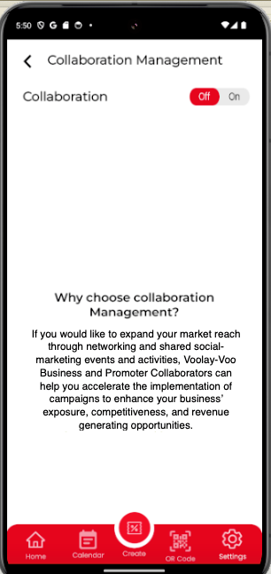

- Add “Availability” text to replace sample text:
“Voolay-Voo Consumer Users are always on and always available to find what they need when they need it. Your availability turned on ensures you are accessible to deliver your brand solutions, services, and messaging at the perfect moment.”
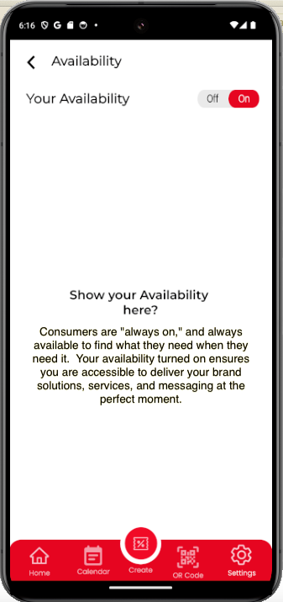

- **THIS MIGHT HAVE ALREADY BEEN ADDRESSED*** Setting Collaboration for an Event and allowing “Edit” permissions for one of the Collaborators is not saved after exiting the Collaboration Management screen and accessing the screen again. In this case, Ravi is granted editing permissions by Om for the Event “om event second for Ravi and puru”. The ‘Edit Events” permission is unchecked after exiting Collaboration Management and accessing it again.
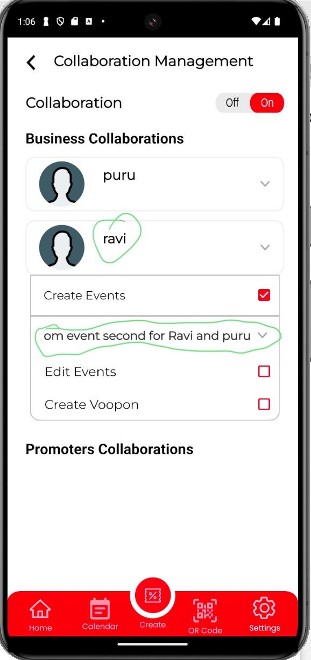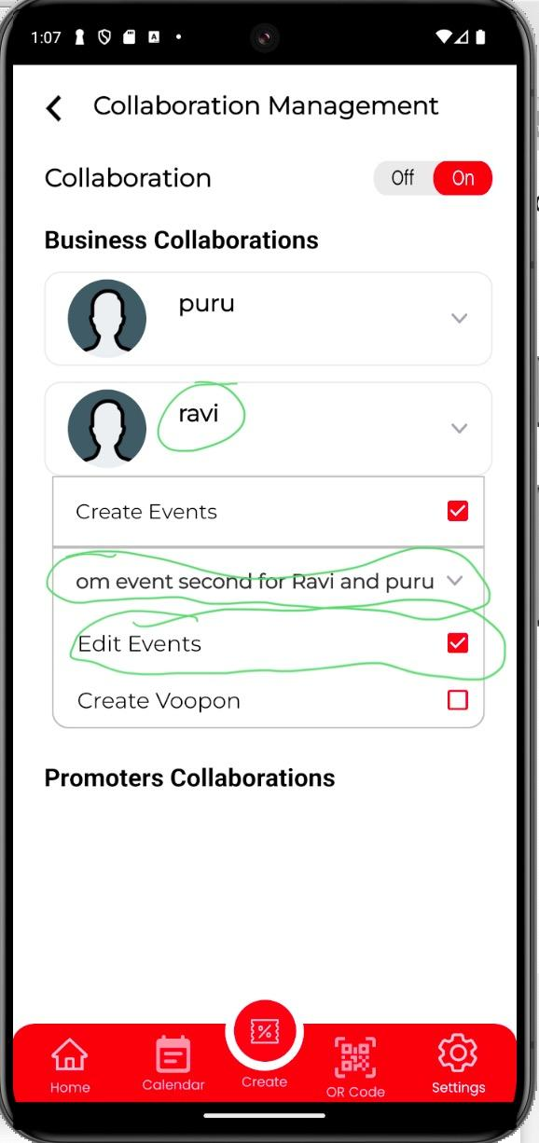

- BUSINESS/PROMOTER WEB PANEL: CREATE VOOPON: Upon SAVING newly created VOOPON, the “SAVE” button does not resolve, therefore, the VOOPON cannot be saved/ceated.

